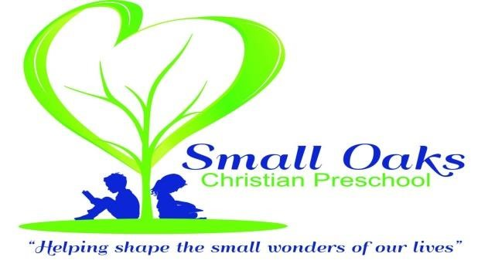

Thank you for choosing Small Oaks Christian Preschool. We are excited to have you join us for the 2024-2025 school year. To register your child please fill out the attached forms, and return to the Small Oaks office with your $75 (non-refundable) registration fee. For our returning your registration fee will be $50.

These three forms must be completed and turned in at the time of registration:

1. Student Intake Form
2. Release Form
3. Emergency Card with photo attached

If you fail to return any of the above listed forms we cannot accept your registration.

The **General Health Appraisal** must be turned in on Orientation night or the first day of school.

**Supply fees** are due at our fall orientation and are non-refundable. The fee is $40 for the 3’s 4’s and 4’s 5’s class. The fee is $50 for the Jr. K class, which includes a magazine subscription.

Our classes for the 2024-2025 school years:

3’s 4’s Class 4’s 5’s Class Jr. K

T/TH 9-11:30 M/W/F 9-12 M-TH 9:10-12:15

$175 $225 $315

**Be Blessed,**

**Rene’ McCormick-Director**

**Nichole Pool-Assistant Director**

**rene@smalloakspreschool.com**