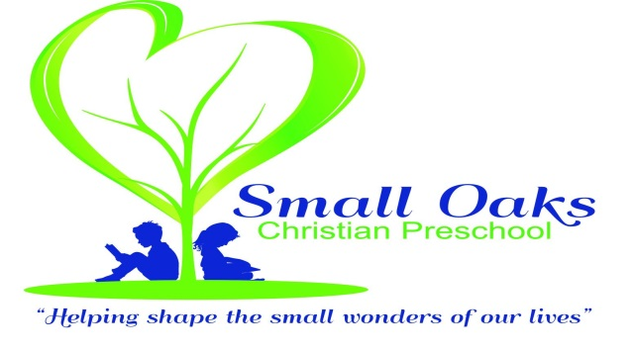
Thank you for choosing Small Oaks Christian Preschool. We are excited to have you join us for the 2021-2022 school year. To register your child please fill out the attached forms, and return to the Small Oaks office with your $75 (non-refundable) registration fee.
These three forms must be completed and turned in at the time of registration:
- Student Intake Form
- Release Form
- Emergency Card with photo attached

The General Health Appraisal must be turned in on Orientation night or the first day of school.

Supply fees are due at our fall orientation and are non-refundable. The fee is $30 for the 3’s 4’s and 4’s 5’s class. The fee is $40 for the Jr. K class, which includes a magazine subscription.

Our classes for the 2021-2022 school years:
3’s 4’s Class 4’s 5’s Class Jr. K
T/TH 9-11:30 M/W/F 9-12 M-TH 9-12:15
$145 $195 $270

Be Blessed,
Rene’ McCormick
Small Oaks Director
rene@smalloakspreschool.com
970-294-1732

